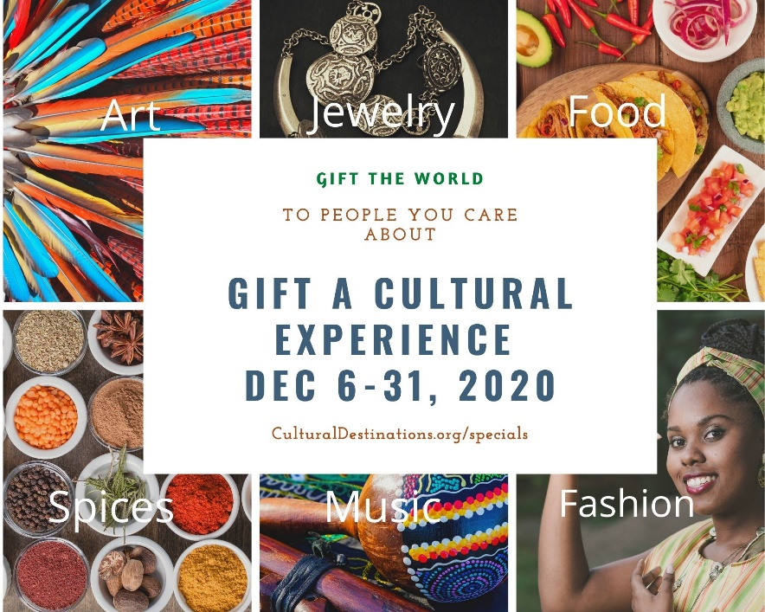

How to List Your Product:
- Have a cultural product or service unique to some country in the world
- Be connected to a community organization which is active in the community and who will recommend your product
- Have a web presence that can showcase your products with prices
- Set up an e-gift card link, so that people can purchase in the following increments ($10, $15, $25, $50 $100)
- Offer exceptional customer service to those who buy your products or service
Once you set the above up, please send the following to corrie@culturaldestinations.org
- A good quality photo of your product or service
- Web link to your products and prices
- Weblink to your e-gift card (include terms and conditions such as how long the gift card will be active)
- Any special promotion you are offering on your product or gift card.
- Signed statement: CulturalDestinations.org and its partners are not responsible for products and services that I ---------- (Business Name) is offering through this website. CulturalDestinations.org and its partners are only promoting your product for a limited time and are not liable for the quality of the product and services nor the delivery of such products and services nor any financial transactions conducted in the sale or exchange of such products and services. CulturalDestinations.org may remove your listing at any time. You agree to provide general reports on the volume of sales generated through this promotion so that CulturalDestinations.org and its partners can evaluate the success of these efforts. I understand that CulturalDestinations.org and its partners are offering this service to my business to help build and grow my business.

